

Course Code: Software Project Design Development
Course Code: CSE 416

Submitted To:
Dr. Mahfida Amjad Dipa
Assistant Professor, Dept of CSE
University of Information Technology and Sciences
Section:7B1
Batch:54
Submitted By:
Most. Samia zaman shammi | 0432320005101058
Sadia Islam | 0432320005101054
Fariha chowdhury | 0432320005101042

PROJECT PROPOSAL AND PLANNING

i. Objectives
The main objective of the proposed project, Lexiconia — World Literature Digital Repository, is to develop a user-friendly web application where users can easily discover, access, and read world literature online. The main objectives of the project are given below:
- Provide Access to World Literature:
To provide a digital collection of classical and modern literature, including novels, poetry, thriller, suspense, philosophy, and historical literature.
- Develop an Online Reading System:
To create a simple and comfortable web-based reading system where users can read books directly from the website.
- Provide Search and Filtering Options:
To allow users to easily find books by using search and filtering options such as title, author, genre, and literary period.
- Improve User Experience:
To provide useful features such as bookmarks, reading history, reading progress, and light/dark reading modes.
- Develop a Responsive Website:
To develop a responsive website that works properly on different devices such as computers, tablets, and smartphones.

ii. Scope
The scope of the project defines the features and limitations of the Lexiconia — World Literature Digital Repository.

In-Scope
Feature Description
User Management Registration, login, user profile, reading history, and bookmarks.
Book Management Book categories, genres, authors, book information, and metadata.
Search System Users can search for books by title, author, genre, and other related information.
Online E-Reader Users can read books directly from the website with features such as font adjustment, reading progress, and light/dark mode.
Author Information The system will provide basic information and biographies of authors.
Admin Panel Administrators can add, update, and remove books and manage users and book information.
Responsive Design The website will work properly on different screen sizes and devices.

Out-of-Scope
Feature Description
Academic Books Academic books, textbooks, and technical books are not included in the current version.
User Publishing Users cannot publish books directly without admin approval.
Online Payment Advanced paid subscription and online payment systems are not included.
Mobile Application Separate Android or iOS mobile applications are not included in the current version.

iii. Feasibility
A feasibility study is conducted to determine whether the Lexiconia project can be successfully developed, operated, and maintained.
Feasibility Type Description
Technical Feasibility The project is technically feasible because it can be developed using commonly available web technologies. React.js or Next.js can be used for the frontend, while Node.js and Express.js can be used for the backend. PostgreSQL can be used to store user, book, and author information. Cloud storage can be used to store digital book files.
Economic Feasibility The project is economically feasible because many of the required technologies are open-source and free to use. Public-domain literature can also be used to reduce content-related costs. Cloud hosting and other services can be selected according to the project requirements and available budget.
Operational Feasibility The system is operationally feasible because it is designed to be simple and easy to use. Users can register, search for books, read books online, and manage their reading activities without special technical knowledge. Administrators can manage books, users, and other content through the admin panel.
Schedule Feasibility The project is schedule-wise feasible because it can be completed within the planned five-month development period. The project will be divided into different phases such as requirement analysis, design, development, content management, testing, and deployment.

iv. Work Breakdown Structure (WBS)
The Work Breakdown Structure divides the project into major activities and smaller tasks. This makes the project easier to plan, develop, and manage.
WBS ID Major Activity Sub-Tasks
1.0 Requirement Analysis and System Planning 1.1 Requirement gathering; 1.2 User and system requirement analysis; 1.3 System architecture planning; 1.4 Database planning
2.0 UI/UX Design 2.1 Website layout design; 2.2 Wireframe development; 2.3 Responsive interface design; 2.4 E-Reader interface design
3.0 System Development 3.1 User registration and login; 3.2 User profile and session management; 3.3 Book search and filtering system; 3.4 Book catalog development; 3.5 Online E-Reader development; 3.6 Bookmark and reading history system; 3.7 Admin panel development
4.0 Content and Metadata Management 4.1 Book collection and formatting; 4.2 Book uploading and storage; 4.3 Genre and category management; 4.4 Author information and metadata management
5.0 Testing, Deployment and Launch 5.1 Unit testing; 5.2 Integration testing; 5.3 Performance and security testing; 5.4 Bug fixing; 5.5 Server setup and deployment; 5.6 Final system launch

v. Gantt Chart
The project is planned to be completed within approximately five months. The major activities and their planned schedules are given below.
TABLE I: PROJECT EXECUTION SCHEDULE
Task ID Task Name Start Date End Date Duration
T1 Requirement Analysis and System Planning Sep 15, 2026 Sep 30, 2026 15 Days
T2 UI/UX Design and Wireframing Oct 01, 2026 Oct 20, 2026 20 Days
T3 Database and System Design Oct 15, 2026 Nov 05, 2026 21 Days
T4 Core System and E-Reader Development Nov 01, 2026 Dec 15, 2026 45 Days
T5 Content and Metadata Management Dec 01, 2026 Dec 31, 2026 31 Days
T6 Testing, Performance and Security Jan 01, 2027 Jan 25, 2027 25 Days
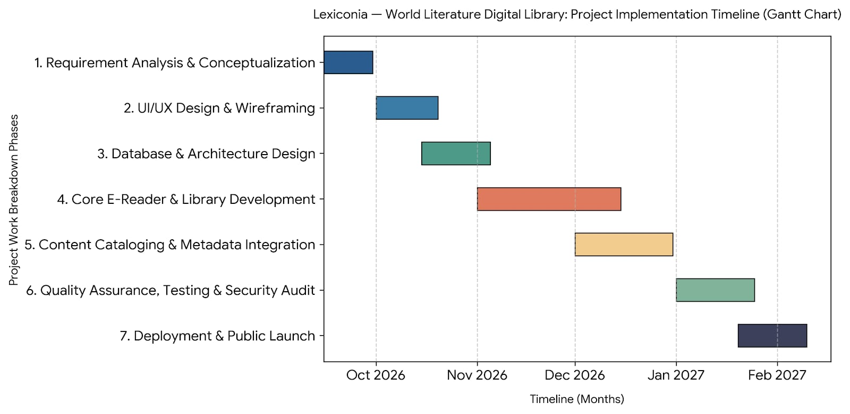

vi. Budget
The estimated project budget includes development, hosting, design, content management, testing, security, and other necessary project expenses.
TABLE II: PROJECT BUDGET
Category Description Estimated Cost (USD) Estimated Cost (BDT)
Software Infrastructure Cloud hosting, database hosting, and storage $450 ৳54,000
UI/UX and Branding UI resources, design assets, and domain $150 ৳18,000
Development Resources Frontend, backend, and E-Reader development $2,000 ৳240,000
Content Management Book formatting and metadata management $300 ৳36,000
Quality and Security Testing, SSL, and security checking $250 ৳30,000
Contingency Fund Unexpected project expenses $315 ৳37,800
Total Estimated Budget Complete Project Execution $3,465 ৳415,800

Conclusion
The Lexiconia — World Literature Digital Repository project is technically, economically, operationally, and schedule-wise feasible. With proper planning, task distribution, and resource management, the proposed system can be developed successfully within the planned project period and estimated budget.

